
2025

ANNUAL

REPORT

2025

PUEBLO COUNTY CORONER’S OFFICE
PUEBLO COUNTY CORONER’S OFFICE

CORONER Dr. Gregory Grahek

1300 N. Santa Fe avenue, Pueblo 81003

719-583-4673

coroner@pueblocounty.us

2025 ANNUAL REPORT

MISSION STATEMENT
T

o provide accurate, professional, and compassionate medicolegal death investigations while securing vital evidence for criminal and civil proceedings. Above all, we are dedicated to serving families during their most difficult moments, delivering the clarity and closure they deserve.

Function of the office
The Office of the County Coroner is established under the Constitution of the State of Colorado, and the Coroner is elected by the citizens of Pueblo County. The Coroner’s Office operates as an independent division within the Pueblo County Government and is funded through the County’s General Fund. The office is staffed by the Coroner, a Chief Deputy Coroner, four full-time Deputy Investigators, four part-time Deputy Investigators, and a full-time administrative team. The department provides continuous service, operating 24 hours a day, 365 days a year.
The Coroner and staff recognize the profound impact of an unexpected death and conduct thorough investigations to support both public safety and the needs of surviving families. Comprehensive forensic investigations facilitate the timely resolution of insurance claims, estate matters, and any associated civil or criminal actions. Information that may appear minor at the time of death can become critical in the months that follow; therefore, a complete and objective investigation ensures that families and the public can have full confidence in the findings. While the Coroner’s Office works in close coordination with law enforcement agencies, it conducts all investigations independently and without bias. The Coroner has the authority to review and/or investigate any death if circumstances warrant. By Colorado Revised Statute, the Coroner’s Office determines the cause of death in all the following circumstances:
· Disease that may be hazardous or contagious, or that may constitute a threat to the health of the public
· Any external violence, unexplained cause or suspicious circumstances or any type of accident
· When no physician is in attendance, or the physician in attendance is unable to certify the cause of death
· Thermal, chemical, radiation injury or criminal abortion
· When death occurs while in the custody of law enforcement officials or while incarcerated in a public institution
· When death is sudden and occurs while person is deemed in good health
· When death occurs in a hospital less than 24 hours after admission

Although criminal death investigations represent only a small portion of the cases handled by the Coroner’s Office, these investigations receive extensive attention due to their complexity and potential legal implications. This thorough approach ensures the strongest possible support for the criminal justice system. The Coroner also plays an important role in public health by identifying and isolating the causes of sudden, unexpected deaths. When an infectious agent or toxic substance is suspected, the family and any individuals who recently had close contact with the deceased are notified so they can seek appropriate medical evaluation or treatment. 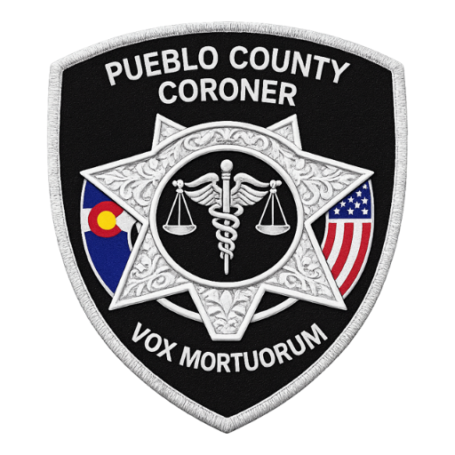

Staff of the Pueblo County Coroner
Coroner: Dr. Gregory Grahek, D-ABMDI

Chief Deputy Coroner: Felicia McQueen, F-ABMDI

Deputy Coroner (Full time): Brian Cruz

Deputy Coroner (Full time): Allen Berner

Deputy Coroner (Full time): Rosalyn Byrd

Deputy Coroner (Full time): Chad Diiorio

Deputy Coroner (Part time): Rob Hudgens

Deputy Coroner (Part time): Matt Goodwin, D-ABMDI

Deputy Coroner (Part time): Jim Cain

Deputy Coroner (Part time): Forrest Wieder

Administrative: Natalie Jensen

expenditures

In 2025, the Pueblo County Coroner’s Office expended $1,429,344: 37% for personnel, 39% for autopsies, and 24% for operating costs. Personnel and operating expenses were stable compared to prior years, while autopsy costs rose due to case volume and statutory requirements.

Description of Reportable Cases

In accordance with Colorado Revised Statue 30-10-606, the following deaths are required to be reported to the Pueblo County Coroner’s Office:
  - Death is or may be unnatural as a result of external influence, violence or injury.
  - Death is due to the influence of or the result of intoxication by alcohol, drugs or poison.
  - Death as a result of an accident, including those occurring at the workplace.
  - Death of an infant or child is unexpected or unexplained.
  - Death where no physician in attendance or when, though attendance, the physician is unable to certify the cause of death.
  - Death that occurs within twenty-four hours of admission to a hospital.
  - Death that occurs within forty-eight hours of a surgical invasive procedure.
  - Death from a disease which may be hazardous or contagious, or which may constitute a threat to the health of the general public.
  - Death occurs from the action of a peace officer or while in custody of law enforcement officials or while incarcerated in a public institution.
  - Death was sudden and happened to a person who was in apparent good health.
  - When a body is unidentifiable, decomposed, charred, or skeletonized.
  - Circumstances that the coroner otherwise determines may warrant further inquiry to determine cause and manner of death or further law enforcement investigation.
It is important to note that although a death may be considered reportable under these guidelines, an autopsy may not be warranted depending on the specific circumstances of the case.

yearly trends

The case volume in 2025 represents a 10% increase compared to 2024. Of the 927 total deaths reported to the Pueblo County Coroner’s Office for evaluation, 770 met statutory criteria and were formally classified as coroner cases. The remaining 157 deaths involved individuals under hospital, nursing home, or hospice care and did not meet the threshold for coroner jurisdiction.

2025 MONTHLY TRENDS

Although case numbers in 2025 showed a modest increase, they remain significantly lower than those recorded during the COVID‑19 period. In 2025, the office also experienced an uptick in hospital and hospice inquiries seeking clarification on whether the circumstances of a death met the statutory criteria for coroner involvement.

AUTOPSIES

O

f the 2,364 deaths in Pueblo County that were reported to the Colorado Department of Health in 2025, 770 cases qualified as coroner cases. Of these 770 cases, an autopsy on some level was performed on 33% of the cases. Depending on the circumstances of the death, 164 full autopsies were performed along with 93 external exams and/or cranial exams. On 16 cases, only toxicology testing was conducted. Autopsies are conducted to determine manner and cause of death, to document disease, to identify injury patterns, or to recover evidence. Along with the physical autopsy, toxicology testing and histology review are performed which may also be useful in determining manner and cause of death. Toxicology tests include those indicating the role of alcohol, illicit drugs, commonly abused prescription and non-prescription drugs, and other abused substances/poisons as needed.

Colorado House Bill 11-1258 was passed in 2011 which mandates forensic autopsies be performed by a board-certified forensic pathologist. This mandate is now also incorporated in Colorado Revised Statute 30-10-606.
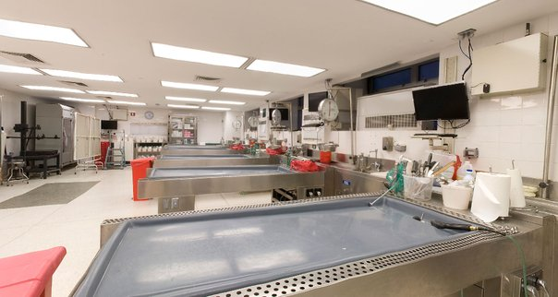
By statute, a forensic pathologist shall perform a forensic autopsy in the following cases:
- The death is known or suspected to have been caused by apparent
criminal violence.
- The death is unexpected and unexplained in an infant or child.
- The death is associated with police action.
- The death is apparently non-natural and in custody of a local, state,
or federal institution.
- The death is due to acute workplace injury.
- The death is caused by apparent electrocution.
- The death is caused by apparent intoxication by alcohol, drugs, or poison, unless a significant interval has passed, and the medical findings and absence
of trauma are well documented.
- The death is caused by unwitnessed or suspected drowning.
- The body is unidentified, and the autopsy may aid in identification.
- The body is skeletonized.
- The forensic pathologist deems a forensic autopsy is necessary to determine
manner and cause of death, to document injuries/disease, or to collect
evidence.
- The deceased is involved in a motor vehicle incident, and an autopsy is necessary to document injuries and/or determine the cause of death.

MANNER OF DEATH
T
he state of Colorado recognizes five classifications of manner of death. They are: Natural, Suicide, Accidental, Homicide, and Undetermined. A death is classified as one of these based on the circumstances surrounding the death and how that cause came to be. Determining manner of death is one of the main responsibilities of the Pueblo County Coroner’s Office and is one of the items that must be reported on the death certificate.

DETAILED BREAKDOWN OF MANNER

NATURAL DEATHS

SUICIDE DEATHS

2025 saw a decrease in suicides by one over 2024. Males continue to dominate the numbers (84%) of suicides. Females account for 16% of all suicides, with 38% under the age of 18 years. Suicides involving the use of firearms consisted of 78%, which is an increase of 7% from 2024.

ACCIDENTAL DEATHS

Accidental deaths represent the second most common manner of death after natural causes and arise from a wide range of circumstances. As shown in the accompanying graph, drug overdoses account for the largest share, with the majority involving multiple substances. (A detailed review of drug overdoses appears later in this report.) Falls are the second leading cause of accidental death, followed by motor vehicle collisions and vehicle‑versus‑pedestrian incidents. The trauma category includes fatalities resulting from impalements, crush injuries, and farming accidents. The youngest accidental death victim was a one‑hour‑old infant, while the oldest was 104 years old. Males accounted for 128 accidental deaths (71%), while females accounted for 53 (29%).


HOMICIDES

As reflected in the following graphs, homicides in Pueblo County have steadily declined after peaking in 2022. Males account for 81% of the victims, with most victims of both genders falling between the ages of 30 and 39. Firearms were involved in 81% of the cases.

Homicide - Method

T
DEATHS OF UNDETERMINED MANNER
he Pueblo County Coroner’s Office strives to provide families with an accurate cause and manner of death for their loved ones. However, in some cases, a cause of death cannot be determined even after a complete autopsy, comprehensive toxicology and histology testing, and a thorough multidisciplinary scene investigation. There are also situations in which the cause of death is evident, but the manner of death cannot be established due to insufficient evidence. Because manner of death must be determined based on a preponderance of evidence, cases that do not meet this threshold are classified as undetermined. For example, an apparent drug overdose may clearly identify the cause of death, but without adequate supporting evidence, the manner of death cannot be distinguished between suicide and accident.

Of the five cases with undetermined manner of death, three were male and two were female. The age range was 12 weeks to 62 years of age.
DRUGS OF ABUSE: POLYDRUG DEATHS
Of the 72 deaths in 2025 attributed to an overdose of drugs, 37 involved the lethal level of more than one drug. All overdose deaths are considered accidental unless evidence shows they were intentional. The most common drugs involved in polydrug deaths are ethanol, opiates, and stimulants (methamphetamine and cocaine).

OVERDOSES BY DRUG - TOTAL 72

T
CHILD DEATHS - 2025

he Pueblo County Coroner’s Office investigated 18 deaths involving individuals under 18 years of age. Of these decedents, ten were male and eight were female. Six cases involved children one year old or younger, two cases involved children between two and ten years old, and ten cases involved youths aged 11 to 17. Accidental deaths were the most common manner of death, with a total of seven, followed by suicide with five cases. For the first time since 2017, there were no juvenile homicides. Four of the juvenile suicides involved a firearm, while the fifth resulted from hanging by ligature. Among the accidental deaths, one involved a fentanyl overdose, four were related to motor vehicle crashes, one resulted from a fall, and one was associated with unsafe sleeping conditions. One case remains pending as the Forensic Pathologist continues the investigation.

Addendum

An additional category added for the 2025 annual report includes the unhoused.
